**Michigan Align Process**

**What is “Aligning” Elements:**

Align enables you to align (or map) your data dictionary (element names, definitions and option sets) to CEDS. The alignment creates a map that can be used with CEDS reports to see how your data dictionary aligns with the CEDS standard, or with others in the field. The reports can also help you identify where data elements are missing, or where duplicate collection efforts are occurring within your own systems.

**CEDS Align Tutorials:** [Learn CEDS Alignment](https://ceds.ed.gov/learnCedsAlignment.aspx)

**Prior to beginning**

1. Identify data that will be aligned – Collection / Data Content Area/Related Content
2. Determine who should be included in the alignment process
   1. Collection and Reporting SME’s
      1. Knowledge of the Collection system business rules is helpful when reviewing existing CEDS elements and their definitions/option sets
      2. An LDU reporting SME is helpful to understanding the reporting rules and fields utilized for output and/or calculations within the report(s)
   2. CEDS Domain Expert
   3. Governance Leads from OIS and OAR
3. All members of the team should have an account set up in CEDS
   1. To set up an account [see the tutorial](https://youtu.be/17U4v4BWsMs)
   2. **NOTE:** All steps below that reference accessing an item in CEDS or downloading/uploading assume you are logged into the website.

**Step-by-Step Instructions for element alignment:**

1. **Create a map** in the CEDS Align tool – [See Align Tutorial for Creating a Map](https://youtu.be/xKlCiEcXcXQ)
   1. The following fields will be required to create the map:
   2. 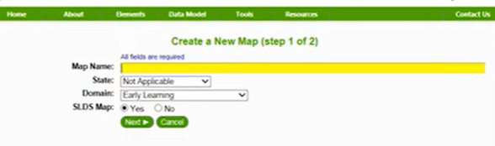
      1. The map name should include State / Data Collection or Content Area / Timeframe that the mapping occurs as we sometimes make several maps or several attempts at mapping. For example “Michigan Entity Educational Master EEM Fall 2023”
      2. Follow the screen prompts and drops downs for the remaining required fields
2. Ensure access to the map is granted to all team members before proceeding [Align 3 Tutorial](https://youtu.be/V6okMJ4dfqQ)
3. Download the Align template for your map ([See CEDS Align Training 3](https://ceds.ed.gov/PDFViewer.aspx?pdfFile=pdf/Align_Module_3_Uploading_a_DataDictionary_V7.pdf&category=%22Uploading%20a%20Data%20Dictionary%20PDF%22))– This is a multi-tab excel spreadsheet
   1. Login to the [CEDS website](https://ceds.ed.gov/whatIsCEDS.aspx)
   2. Download the template from the CEDS Align tool [(Tools/Align)](https://ceds.ed.gov/align.aspx)
      1. Under the heading “Build” select “Download”
      2. Review instructions tab
4. Determine fields / elements that will be loaded with this align template
   1. Consider all fields that relate to the data group and what the “source” data will be such as:
      1. Source Fields from the CEPI Collection (Logical Model) OR Source fields from SLDS Warehouse (Physical Model) - as of 2023, it is recommended to map from the Logical model
      2. Any supporting data from other collections/data sources Fields needed for completing calculations
      3. Fields needed to identify timing, load sequence, record hierarchy, etc.
5. **Once fields are identified, check approved align maps, Master Gaps document and data governance items to see if fields selected have already been mapped/aligned or are in Governance discussions.**
   1. *For immediate needs the Aligned maps are on the SharePoint site,*
6. Add necessary information to the template. (metadata tab)
   1. Read the instructions in the spreadsheet to determine what to add.
      1. Reminder: There should be a row in the spreadsheet for each element/option combination. So, if an element has an option set with seven options, there should be seven rows for that element.
7. Login to the [CEDS website](https://ceds.ed.gov/whatIsCEDS.aspx)
   1. Upload Align Template to CEDS Align tool [(Tools/Align)](https://ceds.ed.gov/align.aspx)
   2. Under the heading “Build” select Create Maps
      1. Fill in required information and select “next.” [Click here for more information](https://ceds.ed.gov/PDFViewer.aspx?pdfFile=pdf/AlignModule-1-Creating-A-Map-V7.pdf&category=%22Creating%20a%20Map%20PDF%22)
      2. Under the “Manage Map” directory select Data Elements/Upload Data Dictionary
         1. Read the instructions on the page then select the “Upload a File” button to navigate to your template containing elements you intend to align. [Click here for more information](https://ceds.ed.gov/PDFViewer.aspx?pdfFile=pdf/Align_Module_3_Uploading_a_DataDictionary_V7.pdf&category=%22Uploading%20a%20Data%20Dictionary%20PDF%22)
8. Aligning
   1. Individually or as a group of Subject Matter Experts (SMEs) – determine the best alignment for each element.
      1. If completed individually, follow the task with a SME group overview and gather consensus that alignment was appropriate.
   2. select an element to align, when you click on the element a dialogue box will open which will auto-populate with the fields you completed in your template.
   3. Using the CEDS domains on the right, you can select the domain and click on an element to view its definition and option set. If a match is found select the box by the element.
      1. Select the level at which the definitions match.
      2. Select the level at which the option sets match.
         1. By completing the above steps, you will help inform the data governance discussions that will follow after alignment processing is completed.
      3. IF THE ELEMENT IS NOT AN IDENTICAL MATCH: In the “Comments” box on the left side, enter:
         1. Your name
         2. Date
         3. CEDS Gap or CEPI Gap
         4. Description of the gap (is it related to the definition, the option set and what are the differences)

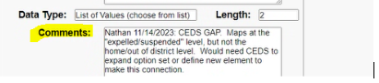

* + 1. Once complete, click the Submit button.
    2. You can repeat this step to select multiple CEDS elements if the Michigan element aligns in various aspects to more than one CEDS elements (definition, option sets, etc.)
    3. If a CEDS element cannot be found that provides a match to the State of Michigan element, select the “Element could not be located in CEDS” box at the top right of the dialogue box.

* + 1. For more information see the CEDS instructions
       1. [Part 1](https://ceds.ed.gov/PDFViewer.aspx?pdfFile=pdf/AlignModule-4-1-AligningElements-To-CEDS-V7.pdf&category=%22Aligning%20Elements%20to%20CEDS%20-%20Part%201%20PDF%22)
       2. [Part 2](https://ceds.ed.gov/PDFViewer.aspx?pdfFile=pdf/AlignModule-4-2-AligningElements-To-CEDS-V7.pdf&category=%22Aligning%20Elements%20to%20CEDS%20-%20Part%202%20PDF%22)

1. Subject Matter Expert (SME) QA Review
   1. Review may occur during the alignment process, if the process is completed in a group.
      1. Even if an analyst completes the review on their own, then a follow-up meeting or series of meetings should occur to review with the selected SME’s.
   2. Once the group agrees that an element is mapped correctly or is not present in the CEDS catalog select the “Internal Review Complete” box at the bottom left of the dialogue box and then lick “update” at the bottom.

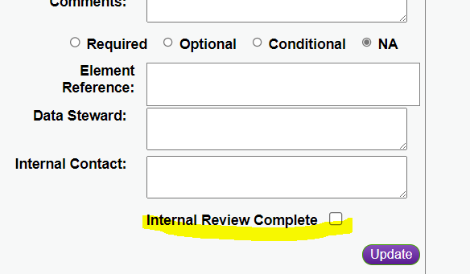

1. To exit and re-enter the map as needed
   1. You can exit and re-enter if you run out of time
      1. If you need to re-enter, go to the CEDS/Tools/Align and under the header “Build” select “Manage Maps”, then select the map you are working on.
   2. To Align an element:
      1. Select the Map Name that you intend to align.
      2. On the “Manage Map” directory, select Data Elements/Align Elements
2. Next Steps
   1. To download the final information
      1. In CEDS, go to the Align tool and under the Build header select Manage Maps
      2. Select the map you want to download
      3. Under Manage Map, select Using the Map/View Reports
      4. Select Data Dictionary + CEDS
      5. Click Next
      6. In upper right click the Options dropdown
      7. Download Full Report
   2. Add the document to SharePoint under the appropriate data group
   3. The align output will be used to inform following processes of the Data Governance – Master Gaps Spreadsheet, ETL Checklist, Data Modeling, etc.

**Master G**a**ps Document**

1. Fields and/or options that do not align well to an existing CEDS element/option are required to be added to the Master Gaps Document on SharePoint
2. Assign roles for the Gaps review work
3. A new meeting series should be created for the same group that aligned the elements and any additional SME’s necessary to discus the gaps and create a recommendation
   1. Discuss each gap and determine a recommended solution
      1. See Gaps Scenarios for additional insight into potential solutions
4. Submit gap recommendations to management team for feedback
5. **IF a Use Case is appropriate copy OIS and OAR Governance Leads to initiate creation of Use Cases for review. ONLY an authorized submitter should submit the Use Case ot GitHub for hte Open Source Community to review.**
   1. This allows for tracking and efficient lines of communication.